EE4007 Tutorial Solutions

λ₀ = 780 nm 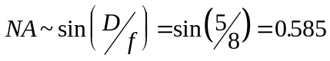
Spot diameter ~ 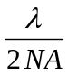 ~ 670 nm
in Radians
Typically the diameter of a CD is ~ 11.6 cm.
The inner diameter beyond which information is stored is ~ 4 cm
∴ r_{outer} ~ 5.8 cm r_{inner} ~ 2 cm
∴ Area available for recording = 9.3x10⁻³ m²
Now let us assume a distance of the order of the spot diameter between spots.
The area occupied per spot will be ~ 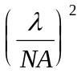 = 1.8x10⁻¹² m²/bit.
∴ the number of bits on the disc can be 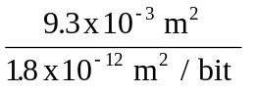 = 5.2Gbits
There are 8 bits/byte
∴ Disk capacity is estimated to be 645Mb.
I have used my own estimates here, including a guess for the numerical aperture of a CD system. Hence my answer may be somewhat fortuitous. However, it does give some feeling for why the capacity of a CD is what it is.
2. 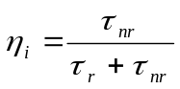
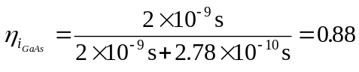
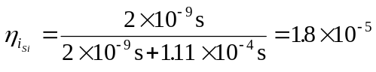
The very low internal efficiency for the Si LED means that virtually no light would be emitted. This can be attributed to the long radiative lifetime of the device, caused by the Si being an indirect bandgap semiconductor.
3. The fraction of photons emitted from the LED can be taken as a good estimate of the external efficiency as, given the internal efficiency ~ 1 all the electrical energy is being converted into light.
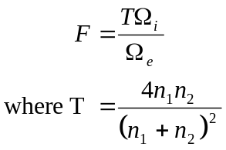
Assuming the refractive index of air is 1 and of GaAs is 3.45
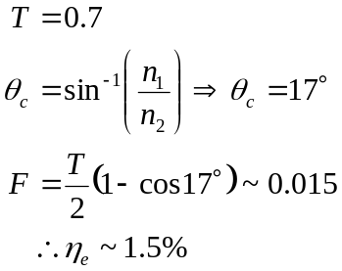
By placing a hemispherical coating on the device
T is increased to 0.90 for transmission into the coating and θ_{c} is increased to 31°.

From the device into the coating: As the coating is hemispherical all the light can be approximated to impinge on the coating to air interface at normal incident ∴θ_{c} is not relevant.
T can be calculated to be 0.92 = F₂
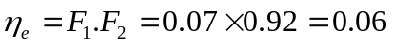
Hence η_{e} is enhanced from around 1.5% to 6% by the addition of the dome, a four fold improvement in the brightness of the LED.

